

Oshwal Association of the U.K

Paper 1
Date of Paper: 23rd June 2017 Return Date: 23rd July 2017
Questionnaire sponsored by North Area, London Marks: ………../100

GET IMMERSED IN ADINATH BHAGWAN

Full Name: ……………………………………………………………………………….

Address: ……………………………………………………………………………………………….

- In his second incarnation, Shree Adinath Bhagwan’s atma was ………………… (1)
(Dev-gati,Yuglik, Manavbhav)

- In his fifth incarnation, Shree Adinath Bhagwan’s atma was ……………………… (1)
(Surudev, Lalitangdev, Mitradev)

- In his fifth incarnation, which devi was Shree Adinath Bhagwan attracted to?
………………………………………………………….. (1)

- What was the name given to Shree Adinath Bhagwan in his fourth incarnation? (1)

- ……………………….....was a friend of Shree Adinath Bhagwan in his fourth incarnation (1)
(Virbuddha, Svayambuddha, Haribuddha)

- In the 4th incarnation Shree Adinath Bhagwan’s Atma was……………………… (1)

- In his sixth incarnation, Shree Adinath Bhagwan’s atma was in …………….…..Shetra (1)
(Bharat, Mahavideha, Airavat)

- In his 12th incarnation, Shree Adinath Bhagwan was…………………..Dev (1)

- Shree Adinathbhagwan was a physician named ………………….in one of his incarnations (1)

- In his 11th incarnation, Shree Adinath Bhagwan’s father’s name was …………………….(1)
(Vajrasen, Vajranabh, Vajrabahu)

- Dhanna Sarthavaha gave………………… for supatradaan (1)

- The second aro was in the …………………….. avsarpini kala (1)
(Sushma-Dushma, Sushma, Dushma-Sushma)

- Marudeva mata gave birth to Rusabh and…………………………… (1)
(Sunanda, Sanmangla, Surupa)

- ……………………was the son of Sumangla. (1)
(Bahubali, Bharat, Yuglik)

- In his 12th incarnation, Shree Adinath Bhagwan’s atma lived for ……………..sagaropams (1)
(16, 33, 30)

- Shree Adinath Bhagwan was married to Sunanda and ………………….. (1)

- The name of Shree Bahubali’s mother was…………………………. (1)

- Shree Adinath Bhagwan’s Moksha Kalyanak occurred in …………………..Tirth. (1)

- In his 6th incarnation, Shree Adinath Bhagwan’s atma was married to princess……………(1)
(Sundari,Bansari, Shrimati)

- In his first incarnation, Shree Adinath Bhagwan met Guru ……………… (1)
(Dharmabodh, Dharmajeet, Dharmaghoshsuriji)

- Shree Adinath Bhagwan was born in the ………………..clan (1)
(Hari, Ishvaku,Jain),

- Shree Adinath Bhagwan had ……………….wives when he was a householder (1)
(2, 1, 0)

- Shree Adinath Bhagwan was born in ………………aro (1)
(1, 3, 4)

- Shree Adinath Bhagwan went to Moksha on ………………………… (1)
(Girnar, Shatrunjay, Ashtapad)

- Shree Adinath Bhagwan’s mother saw ……………….in the first dream (1)
(Elephant, Bull, Lion)

- Shree Adinath Bhagwan took Diksha together with …………………people (1)
(300, 1000, 4000)

- Shree Adinath Bhagwan’s Chadmast kala was………………….years (1)
(125, 1000, 84 purva)

- Shree Adinath Bhagwan’s name is famous in the ……………………. (1)
(Bible, Koran, Veda)

- Shree Adinath Bhagwan’s Lanchan is the…………………………………. (1)
(Lion, Bull, Elephant)

- Shree Adinath Bhagwan fasted for …………………………..days. (1)
(400, 360, 200)

- Shree Adinath Bhagwan had……………………..Sons (1)
(99, 98,100)

- After Shree Adinath Bhagwan achieved Nirvana, Indra made ……………stoop (1)
(1, 2, 3)

- In his first incarnation, Shree Adinath Bhagwan fed…………………to muni (1)
(milk, ghee, food)

- Shree Adinath Bhagwan’s mother was called………………………….. (1)
(Trishla, Karuna, Marudeva)

- Shree Adinath Bhagwan’s first son was called…………………………….. (1)
(Bahubali, Nami, Bharat)

- Shree Adinath Bhagwan is the ………………………..Bhagwan (1)
(first, fifth, twentyfourth)

- Shree Adinath Bhagwan is also known as ………………………………. (1)
(Gyanputra, Vardhman, Rushabhdev)

- Shree Adinath Bhagwan was ………………….Gau tall (1)
(1, ½, ¼ )

- Shree Adinath Bhagwan’s son was named ……………………………….. (1)
(Shreyans, rushabhsen, Bahubali)

- Shree Adinath Bhagwan lived for……………………… (1)
(84 lakh, 84 purva, 84 lakh purva)

- Shree Adinath Bhagwan in his incarnation as Dhanna Sarthvaha attained………………. (1)
(Samkit, Charitra, Moksha)

- Shree Adinath Bhagwan took Diksha on ……………………….. (1)
(falgun sud 8, falgun vad 8, vaishakh sud 3)

- Shree Adinath Bhagwan had…………………………..ganadharas (1)
(14, 64, 84))

- Shree Adinath Bhagwan’s Grandson was the atma of …………………Tirthankara (1)
(first, tenth, twentyfourth)

- Shree Adinath Bhagwan’s …………………..kalayanaks are on the same date(tithi) (1)
(2, 3, 4)

- Shree Adinath Bhagwan’s ……………………..kalyanak is famous as Meruteras (1)
(Janma, Diksha, Moksha)

- Shree Adinath Bhagwan’s first ganadhara was………………………… (1)
(Bharat, Pundrik, Gautam)

- Shree Adinath Bhagwan’s ……………………incarnation is famous for jivdaya (1)
(Lalitang, Dhan, Jivannand)

- Shree Adinath Bhagwan’s Chayan happened on…………………………. (1)
(Falgun vad 4, Vaisakh vad 4, bhadarva vad 4)

- Shree Adinath Bhagwan’s first Parnu was assisted by………………………. (1)
(Tapas, Shreyans, Bharat)

- Shree Adinath Bhagwan had ……………………gano (1)
(11, 80, 84)

- ………………………Shree Adinath Bhagwan’s Moksha, Marudeva Mata went to Moksha (1)
(Before, After)

- Shree Adinath Bhagwan came as …………………in his incarnation as deva (1)
(Saudharma, Achhyat, Sarvarth)

- Shree Adinath Bhagwan’s rashi was ……………………. (1)
(Vrushabh, Dhan, Lion)

- Shree Adinath Bhagwan took Diksha under a ……………………….tree (1)
(Ashoka, Vad, Champak)

- Shree Adinath Bhagwan was doing the tapa of ……………….when he attained Kevalgyan. (1)
(Chatth, Attham, Chothbhakt)

- Shree Adinath Bhagwan took Diksha in the city of…………………………….. (1)
(Ayodhya, Vinita, Swavasti)

- Shree Adinath Bhagwan’s first Sadhviji was……………………… (1)
(Sundari, Brahmi, Chandana)

- Shree Adinath Bhagwan’s yaksha is ………………………. (1)
(Kapardi, Matang, Gaumadh)

- Shree Adinath Bhagwan’s ………………………achieved Kevalgyan in the mirror room (1)
(Mother, son, daughter)

- Shree Adinath Bhagwan’s birth Nakshatra is ………………………. (1)
(Utttarshadha, Uttarafalguni, Uttarabadrapad)

- Shree Adinath Bhagwan was doing …………………tapa when he took Diksha (1)
(Chatth, Attham, Chaturbhakta)

- Shree Adinath Bhagwan’s atma was very amorous during in incarnation as…………(1)
(Jivanand, Dhan, Lalitang)

- Shree Adinath Bhagwan attained Kevalgyan in ………………………..city. (1)
(Vinita, Purimatal, Ayodhya)

- Shree Adinath Bhagwan used the vaitaliya Shastra to convince his ……. sons to take diksha. (1)
(1,2, 98)

- Shree Adinath Bhagwan made ………………………..sculptures (1)*
(10, 100, 1000))

- Shree Adinath Bhagwan showed ……………..arts for men (1)
(64, 72, 16)

- Shree Adinath Bhagwan showed …………………arts for women (1)
(64, 72, 16)

- Shree Adinath Bhagwan’s son ………………was not achieving Kevalgyan because of his pride (1)
(Bharat, Bahubali, Shreyansnath)

- Kutchh- mahakutchh who took Diksha at the same time as Shree Adinath Bhagwan became…………
(Tridandi, Tapas, Sanyasi) (1)

- Shree Adinath Bhagwan went to Moksha in ………………… (1)
(Siddhasana, Padmasan, Karyotsarg)

- Shree Adinath Bhagwan’s Moksh parivar is ……………………. (1)
(0, 10000, 1008)

- Shree Adinath Bhagwan stayed in the womb for …………………..days (1)
(274, 277, 270)

- Shree Adinath Bhagwan’s yakshini is …………………… (1)
(Padmavati, Chakeshwari, Laxmiji)

- Shree Adinath Bhagwan’s daughter Sundari did Ayambil tapa for ………………years (1)
(1000, 6000, 60000)

- Shree Adinath Bhagwan climbed Shatrunjay from ………………………. (1)
(JaiTaleti, Aatupur, Palitana)

- When Shree Adinath Bhagwan went to Moksha, he was on his…………….fast. (1)
(third, fifth, sixth)

- Shree Adinath Bhagwan went to …………………………..for 99 purva years. (1)
(Shatrunjay, Ashtapad, Ginar))

- In following a life experience of Shree Adinath Bhagwan ……………….Tapa is done. (1)
(Shatrunjay, Varsi, Shreni)

- Shree Adinath Bhagwan became the first…………………………….. (1)
(Ganadhar, Raja, Chakravarti)

- Shree Adinath Bhagwan’s atma had caused pain to ……………oxen (1)
(300, 400, 500)

- Shree Adinath Bhagwan had broken his fast with …………pots. (1)
(108, 1008, 101)

- Shree Adinath Bhagwan’s Janma Kalyanak was in ………………..city. (1)
(Vinita, Ayodhya, Shravasti))

- Shree Adinath Bhagwan went to Moksha in the ………………..Nakshatra (1)
(Uttarashadha, Swati, Abhijit)

- At the time of Shree Adinath Bhagwan’s Kevalgyan, a ……………….ratna (jewel) appeared. (1)
(woman, Moksha, Chakra)

- A person like Shree Adinath Bhagwan and an attitude (bhav) like ……………….. would only happen if one had the good fortune from previous birth. (Marudeva, Bharat, Shreyans) (1)

- Shree Adinath Bhagwan went to Moksha in ………………….Aro. (1)
(Dushamsushama, sushamdushama, Sushama)

- Shree Adinath Bhagwan’s relationship with Shreyans was in his ………….incarnation. (1)
(3, 9, 13)

- Bharat Maharaja was the first person who ………………a sadhu when he attained Moksha (1)
was / was not)

- Shree Adinath Bhagwan’s ………………….. sat in a shibika to take Diksha (1)
(Chandraprabha, Sudarshna, Uttarkura)

- The person to help Shree Adinath Bhagwan break his fast for the first time went to ………………………(1)
(Sarvarthsiddh, Moksha, Bhavanpati)

- With Shree Adinath Bhagwan his ………………grandsons also died. (1)
(99, 1, 8)
- …………………. Fortnights after Shree Adinath Bhagwan went to Moksha, the 3rd Aro finished. (1)
(30, 89, 90)

- During Shree Adinath Bhagwan’s time as Tirthankar, there were a total of……….Bhagwans in Bharatshetra (1)
(1, 5, 20)

- Shree Adinath Bhagwan’s ……………………..acquired a low caste (gotra) karma. (1)
(Ganadhar, Son, Grandson)

- Shree Adinath Bhagwan first made a statue of …………………. (1)
(Blacksmith, Carpenter, Potter)

- The first Kulkar (leader) amongst Shree Adinath Bhagwan’s ancestors was…………………….. (1)
(Chakshushman, Nabhiraja, Vimalvahan)

- Shree Adinath Bhagwan had …………..gyans from birth. (1)
(5, 3, 1)
- Shree Adinath Bhagwan was in the ………………… Kshetra (1)
(Airavat, Mahavideha, Bharat)

- Shree Adinath Bhagwan was in the ………………….kal (1)
(Utsarpini, Avsarpini)

TOTAL: 100 MARKS

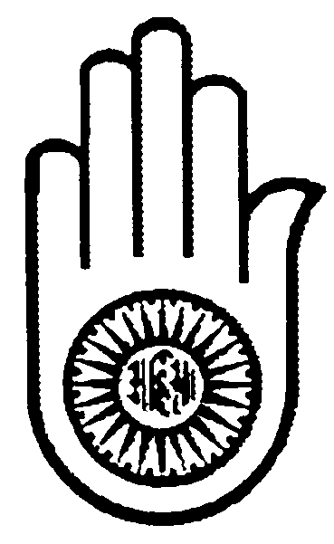

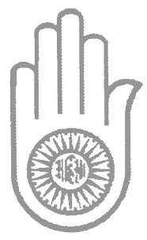
Registered Office: Coopers Lane Road | Northaw | Herts. EN6 4DG
Registered in accordance with the Charities Act, 1960 | Charity Registration Number 267037
Non-Violence

Non-Violence
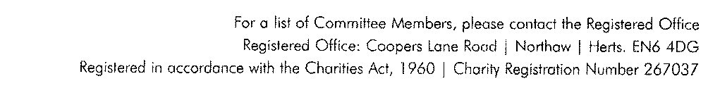
Non-Violence
Registered in accordance with the Charities Act 1960. Charity Reg No: 267037
Non-Violence
Registered in accordance with the Charities Act 1960. Charity Reg No: 267037

